How to open the animated tutorial file (swf)? Open the file with the programme “Internet Explorer”. The following window appears.
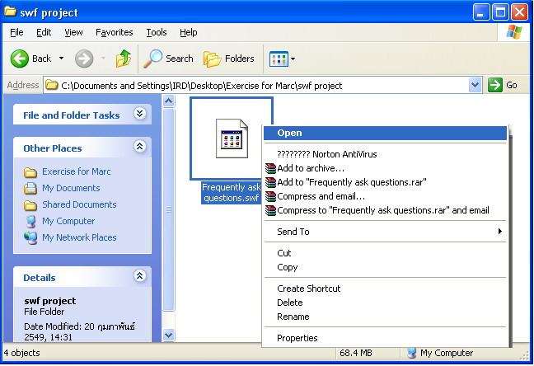

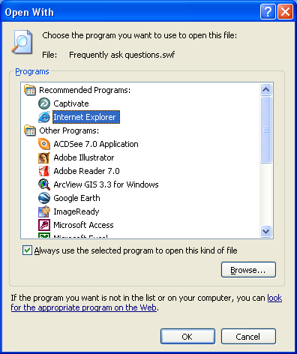
Select the programme “Internet Explorer”

The following window appears.

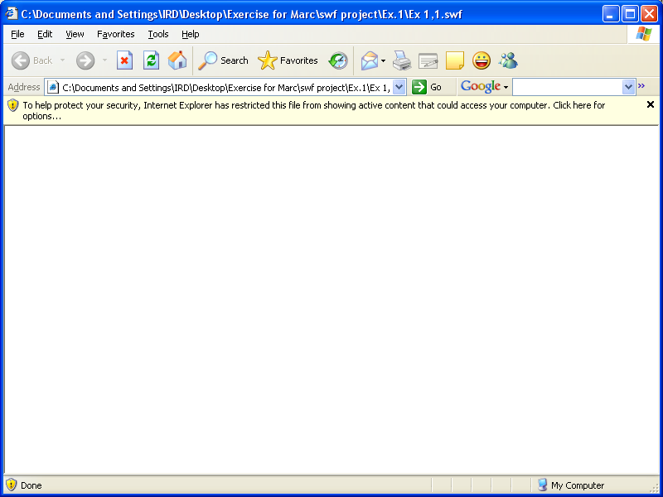

Click at the information bar and select Allow Blocked Content…

The Security Warning dialogue box opens. Click the Yes button to continue.

